EXTENDED ABSTRACT TEMPLATE FOR IASTA-2016

M. K. FIRSTNAME¹, A. SECONDNAME² AND L.S. THIRDNAME²

¹Institute for Aerosol Science & Technology, Department of Chemistry, University of Mumbai,
Fort, Mumbai – 400 001, India.

²Department of Chemistry, University of Jaipur, Jaipur – 302 004, India.

Keywords: WWWWW, XXXXX, YYYYY, ZZZZZ.

INTRODUCTION

The abstracts produced should be camera-ready, and from TWO to FOUR pages long on separate sheets of paper. On the first page of the abstract, start typing text here (about 7cm from the top of the typing area). Text on the next pages can start at the top of the typing area (where the title is on this page). All parts of the abstract should lie in a box 240 mm high and 165 mm wide. There should be a top margin of 29 mm depth and a left margin 23 mm wide. Times New Roman font is preferred, and you should use a character size of 11pt. The title should be in bold capitals, the authors’ names should be in capitals, and the addresses of authors should be in lower case. All these should be centred.

METHODS

You can include up to four keywords or keyphrases, as shown. You should try to use, if possible, categories shown on the abstract classification form. For example, if you wish to indicate that your work is related to aerosol-cloud interactions, then use this form of words (as they appear on the classification form) instead of some permutation such as cloud-aerosol interactions. This will allow us to construct a keyword index to connect related papers.

Pages should not be numbered. You may arrange your text under headings, in capitals and centred. Figures and Tables may be included in the abstracts, but please make sure that they all have a caption, and that they are numbered consecutively using Arabic numerals. The font used in captions can be smaller than used elsewhere, but be advised that anything smaller than 10pt may become illegible when reduced (slightly) for printing. Make sure that the caption fully describes all the features in the Figure or Table. Vertical lines in tables should be avoided.

Month | Measured density (g/cm3) | Predicted density (g/cm3)
January | 0.4 | 121
February | 0.7 | 379
March | 0.9 | 845
May | 1.3 | 1030
June | 2.4 | 15280

Table 1. Comparison between theoretical predictions and experimental measurements.

References should be made in the style (Bakshi, 1975), or (Alexander and Nathan, 1986; Finn et al., 1998) or simply refer to Finn et al. (1998). Examples of journal articles, Conference Proceedings and book references are shown overleaf.

CONCLUSIONS

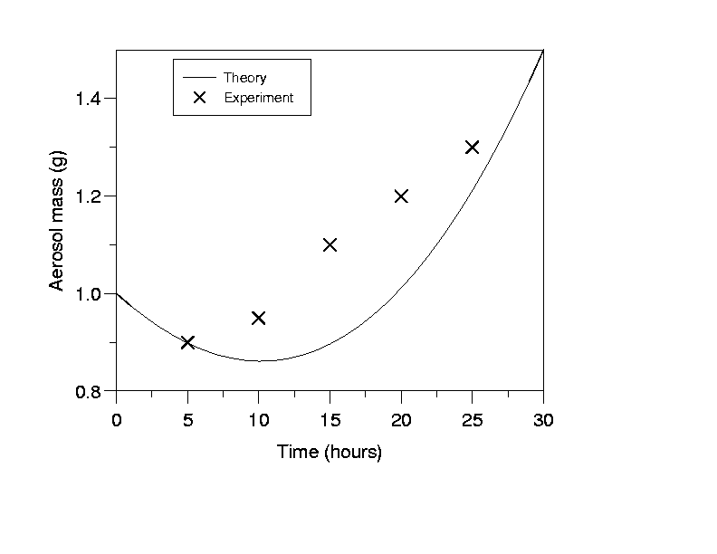
Figure 1. This is the sort of Figure which illustrates good agreement between theory and experiment.

ACKNOWLEDGEMENTS

This work was supported by the Board of Research in Nuclear Science under grant A1/001.

REFERENCES

Alexander, F.R. and J.O. Nathan (1986). An Introduction to Ultrasonic Nebulisation, (Cambridge University Press, Cambridge, U.K.).
Chapman, D.H. (1975). Optical scattering from combustion aerosols, J. Aerosol Science 36, 3456.
Finn, P., G.N. Diver and K.T. Wake (1998). Aerosol measurements in Iceland, in Proc. 13th Int. Conf. on Marine Aerosols, Reykjavik (Wiley, New York), 631.

